Czech-Austrian Winter and Summer School

Impact of renewable-regulation on companies

Bemš, Julius
Schury, Christoph
Sokol, Radoslav

Co-operating Universities



Financial support by

Prague and Vienna, 2011

Content
Content 2
Figure 2
Table 2
1. Introduction and General information 3
2. Abstract 3
3. General Information about the Energy Mix 4
4. The start of the RES-Regulation 8
5. Impact on Electricity Prices 11
6. Impact on Companies 12
7. Conclusion 14
References (Literature) 15

Figure
Figure 1: European Total Energy Production 3
Figure 2: Installed capacity in Czech republic 5
Figure 3: Net produced electricity for January and February 2011 in Czech Republic 5
Figure 4: Installed power in Photovoltaic in Czech Republic(green column) 6
Figure 5: Produced Energy in Austria 2010 7
Figure 6: Portion of production from various RES in Czech Republic(PV is yellow) 9
Figure 7: Portion of financial support for RES in Czech Republic(PV is yellow) 9
Figure 8: Portion of production from various RES in Austria 10
Figure 9:Portion of financial support for RES in Austria 11
Figure 10: Base Load relative prices changes between years 2010/2011 for a range of 1650 Mwp - 2000 MWp of available capacities in PV 11
Figure 11: Peak Load relative price changes between years 2010/2011 for range of 1650 MWp - 2000 MWp of available capacities in PV 12
Figure 12: SKODA Auto a.s. (Sensitivity Analysis) 13
Figure 13: VOEST Alpine (Sensitivity Analysis) 13

Table
Table 1: Energy Mix in the Czech Republic 5
Table 2: Energy Mix in Austria 7
Table 3: RES-Target for all EU-members 8

1. Introduction and General information

2. Abstract
In the last years the awareness for renewable resources as main energy sources was raising progressively. Even though national governmental furtherance’s are trying to develop a framework to force this trend, in whole Europe we are far away from a consistent renewable energy solution. Concerning to Figure 1, around 80% of Europeans total energy production comes from not-renewable resources (e.g. Coal, Oil and Nuclear Power). To work against this bad energy production situation and to cope with the upcoming pressure of forcing renewable resources (RES) as major energy source governments have to think about a new regulatory framework to promote renewable as well as investments in those energy sources. A few governments started to think already about such frameworks to shift their energy consumption from not-renewables to renewables. But how does this changing policy affects companies? In our seminar paper we will outline the impact of a regulatory framework for renewable resources on companies and energy producers. Especially the difference between Austria’s and Czech’s energy mix – Austria is right now producing more renewable energy than Czech – is important for our work.

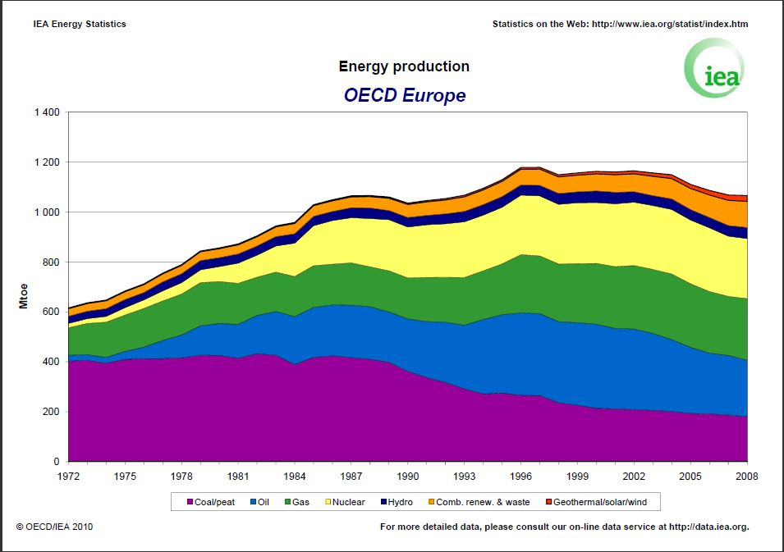
Figure 1: European Total Energy Production
<http://www.iea.org/stats/pdf_graphs/25PROD.pdf>, (26.03.2011)

To create a proper comparison between the countries, we will cover essential energy sources and renewable energy sources (sun, wind, water, biomass), which can be found in the Austrian and in the Czech energy mix to see the effect of the regulatory framework for renewable resources (RES).

Basically, electricity from renewables is much more expensive than electricity from regular energy sources. It is mostly caused by its unpredictability. For the changes in electricity prices, we will use the result of research from Czech Technical University in Prague (Sokol, Bemš) and this paper will cover the impact of higher electricity prices on companies in energy sector such as transmission system operators, distributors and we will try to cover also industrial companies which are major consumers of electricity.

As a relevant data we will use historical price of electricity distribution and transmission, which is tightly correlated with installed power in renewables. The price of transmission and distribution is essential in final electricity price. And also we will cover the price of electricity forward contracts. These are major forming factors of price. After this part we will find a few relevant companies with published annual report on web site and we will make sensitivity analysis of increasing electricity price on earnings.

Due to the observed impact we get from this analysis, a judgment about the strength of the impact is possible for an Austrian company and a Czech company. Therefore the sensitivity analysis will show the impact for some data.

3. General Information about the Energy Mix
In this part the Energy Mix of Czech Republic and Austria will be analyzed. This information is necessary for the amount of used renewable energy and in the next step for the impact of renewable regulation.

Energy Mix of the Czech Republic

Typ | Installed capacity [MW] | Produced el. [GWh] (netto)
 | as at 28.2.2011 | 01/2011 + 02/2011
Steam power plant | 10766,2 | 8185,2
Combined steam-gas power plant | 590,72 | 669,8
Gas power plants | 448,15 | 669,8
Hydro power plants | 1052,25 | 491,9
Pump power plants | 1146,5 | 110,8
Nuclear power plants | 3900 | 5134,4
Wind power plants | 216,6 | 189,7
Photovoltaic power plants | 1979,76 | 189,7
SUM | 20100,18 | 14781,8
Table 1: Energy Mix in the Czech Republic
<source: http://www.eru.cz>, (03.05.2011)

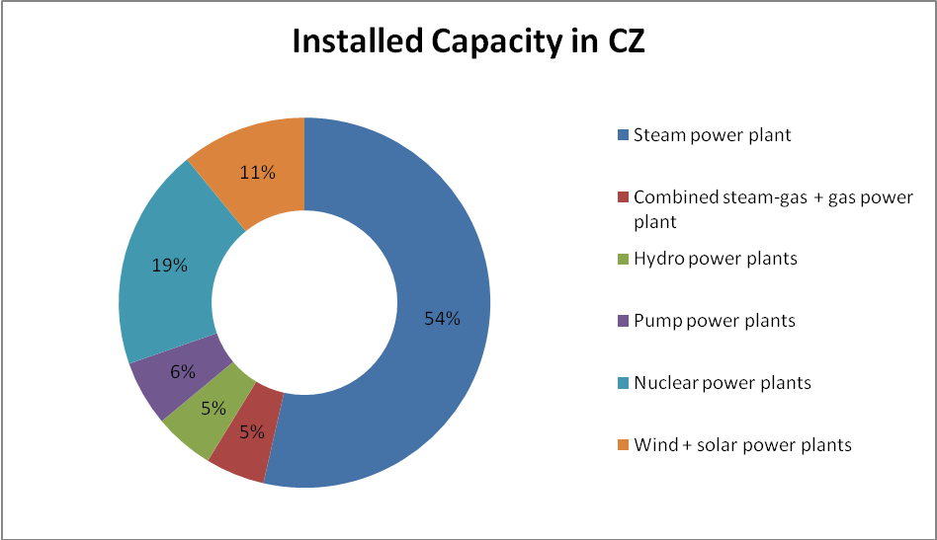
Figure 2: Installed capacity in Czech republic
<source: http://www.eru.cz>, (03.05.2011)

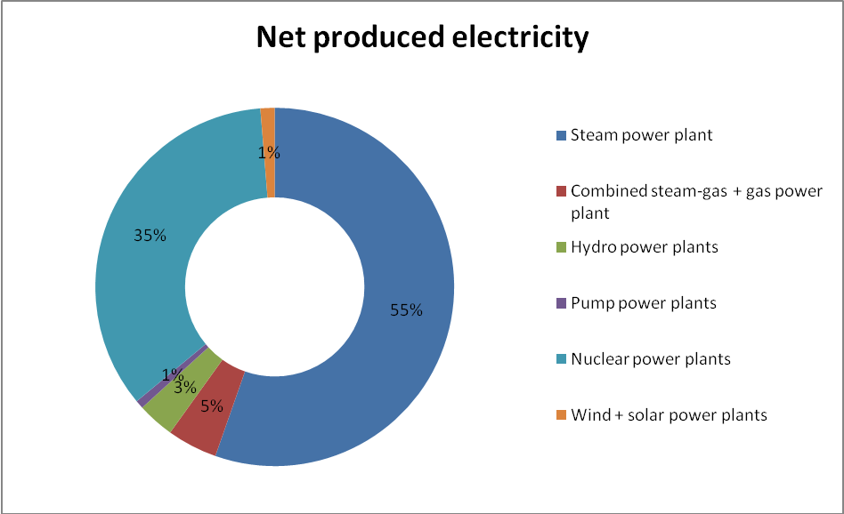
Figure 3: Net produced electricity for January and February 2011 in Czech Republic
<source: http://www.eru.cz>, (03.05.2011)

The first graph shows the installed power for the main electricity sources in Czech Republic. The total installed power is about 20GW at the end of February 2011.
The second graph shows the net produced electricity (gross decreased by own power plant consumption) from the power sources. This is an indirect proof of conventional power sources high utilization and low utilization of renewable power sources. Please take into consideration the fact, that the produced electricity reaches from January to February of 2011, so we can expect a double (or more) production from photovoltaic power plants in summer. The data for the just 2 months were used, because at the end of the year 2010 a lot of new photovoltaic plants were connected to the grid and older data would be obsolete and useless. (http://www.eru.cz)

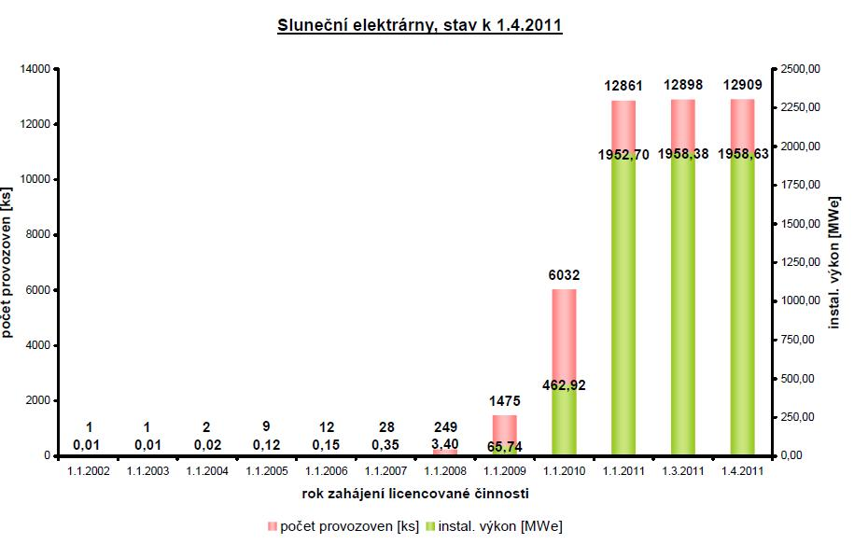
Figure 4: Installed power in Photovoltaic in Czech Republic(green column)
<http://www.eru.cz>,(03.05.2011)

As we can see at Figure 4, the installed power in Photovoltaic rapidly increased and this affects the Czech energy market significantly.

3.2. Energy Mix of Austria

Typ | Produced el [GWh] (netto) | %
Run-over-River Plant | 29.865 | 43,3
Thermal power Plant | 23.382 | 33,9
Storage power Plant | 13.105 | 19
Wind, PV, Geothermic | 2.000 | 2,9
Other | 621 | 0,9
Table 2: Energy Mix in Austria
<http://oesterreichsenergie.at/startseite.html>, (15.05.2011)

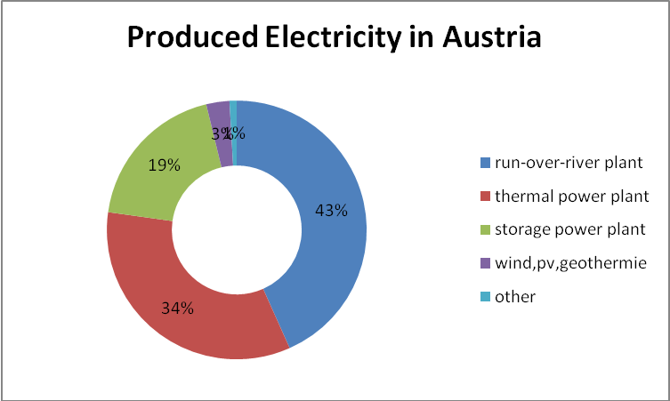
Figure 5: Produced Energy in Austria 2010
<http://oesterreichsenergie.at/startseite.html>, (15.05.2011)

Figure 5 (in combination with Table 2) shows the Austrian Energy mix and the produced electricity in the year 2010. In total Austria produced around 68.973 GWh. The main part of the electricity is produced by so called run-over-river plants, which uses water to create electricity. Basically Austria produces a lot of energy out of water, thats why we can achive the goal of using 20% RES in our Energy Mix. In 2004 around 70% of the in-land produced energy was from RES.
<http://ec.europa.eu/energy/energy_policy/doc/factsheets/country/at/mix_at_de.pdf>, (15.05.2011)

4. The start of the RES-Regulation
The EU officer’s desire is to produce 20% of electricity from renewable sources until the year 2020. Following table documents the targets for all EU member countries.

 | Target 2020 [%] | Assumption [%] | deviation
Austria | 34 | 34,2 | 0,2
Belgium | 13 | 13 | 0
Bulgaria | 16 | 18,8 | 2,8
Cyprus | 13 | 13 | 0
Czech rep. | 13 | 13,5 | 0,5
Denmark | 30 | 30,4 | 0,4
Estonia | 25 | 25 | 0
Finland | 38 | 38 | 0
France | 23 | 23 | 0
Germany | 18 | 19,6 | 1,6
Greece | 18 | 20,2 | 2,2
Hungary | 13 | 14,7 | 1,7
Ireland | 16 | 16 | 0
Italy | 17 | 16,1 | -0,9
Latvia | 40 | 40 | 0
Lithuania | 23 | 24 | 1
Luxembourg | 11 | 8,9 | 2,1
Malta | 10 | 10,2 | 0,2
Netherlands | 14 | 14,5 | 0,5
Poland | 15 | 15,5 | 0,5
Portugal | 31 | 31 | 0
Romania | 24 | 24 | 0
Slovakia | 14 | 15,3 | 1,3
Slovenia | 25 | 25,3 | 0,3
Spain | 20 | 22,7 | 2,7
Sweden | 49 | 50,2 | 1,2
Great Britain | 15 | 15 | 0
Table 3: RES-Target for all EU-members
<http://www.enviweb.cz/clanek/energie/84803/eu-plni-zavazky-do-2020-obnovitelne-zdroje-presahnou-20>, (03.05.2011)

The target for Czech Republic
The target for Czech Republic in 2010 was producing 8% of electricity from renewables. Therefore the government decided to support renewable sources by donations. ERU (Czech regulator) calculated the “fair price” for electricity produced from various renewable sources. The “fair price” means price which guarantees return in some time period. For example, for photovoltaic panels this return period was 15 years. ERU sets the fixed price, which the distributor company will pay to the energy producer. This price is based on the different renewable source types. ERU also sets the price, which the retail customer (or company) will pay for renewable sources support. This payment is actually set to 370 CZK/MWh (14.8 EUR/MWh), which is 223% of payment in the year 2010. We should also take into consideration that we have 20% VAT, so the final support for RES in the year 2011 is 17.8 EUR/MWh. (http://www.eru.cz)
Everything seemed to be fine except the fact, that politicians passed a law which states, that the support price, which distribution company pays to producer, can decrease maximum by 5% per year. Investment costs dramatically dropped in the year 2010 due the cheap photovoltaic panels, also due the stopping solar boom in Western Europe and moving all unused panels to Czech Republic, Slovakia, etc. After this drop in investment costs and still high support prices for producers, this caused inadequate gains for the producers. As shown in the following images, expected the production from Photovoltaic, which is 25% from all RES in the year 2011, because Photovoltaic-owners get 68% of financial support. (http://www.eru.cz)

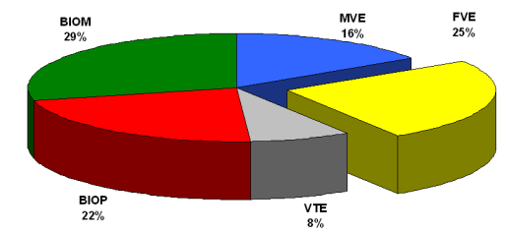
Figure 6: Portion of production from various RES in Czech Republic(PV is yellow)
<source: http://www.eru.cz>, (03.05.2011)

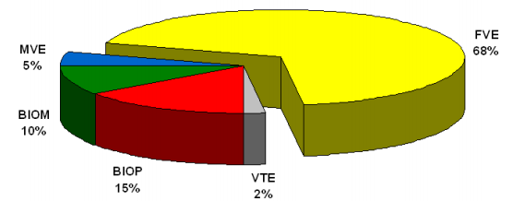
Figure 7: Portion of financial support for RES in Czech Republic(PV is yellow)
<source: http://www.eru.cz>, (03.05.2011)
The target for Austria
The Austrian target for 2020 is to produce 34% of the energy out of RES, which seems to be easily to achieve, because also in 2005, where Austria should have an RES-part of 23%, Austria achieved the target. Austria regulates in the same way as the Czech Republic the issue with the RES. Since 2002 Austria has a law for the implementation of RES, where they handle the prices and the volume of the RES. In 2011 the market price for eco-friendly energy (which is not the price for consumer, it's the price for base load energy) is 60,39 Euro/MWh. <http://www.e-control.at/de/statistik/oeko-energie/aktueller-marktpreis-gem-par-20-oekostromgesetz>, (15.05.2011)

A big part in the law is also the payback for the feed-in of renewable resources. The main renewable resources for the payback in 2010 were wind power and biomass. For wind power the average payback in 2010 was 7,76 Cent/kWh and for biomass the average payback in 2010 was 13,56 Cent/kWh. Even though there is not such a high amount for supported PV Panels, the support for PV is 52,76 Cent/kWh, which is in fact the hightes support. Basically PV gets the high support because they have really high investment costs, to generate more energy than you need. Geothermic is not that popular in Austria. That is why they do not have enough feed-in and the support is rather low. For whole Austria the total payback reached in 2010 587,8mil EUR. Because of high volatility of the produced RES amount, the payback can also vary a lot. To force more RES, the Austrian government assumes that there will be a growing number of supported renewable resource amounts. Especially wind will take a leading part in this issue. In the following figures the production and the support for various RES is shown. This makes it even clearer, how important wind energy is. (water energy is excluded, because private once cannot produce energy out of water) <http://www.e-control.at/de/statistik/oeko-energie/oekostrommengen>, (15.05.2011)

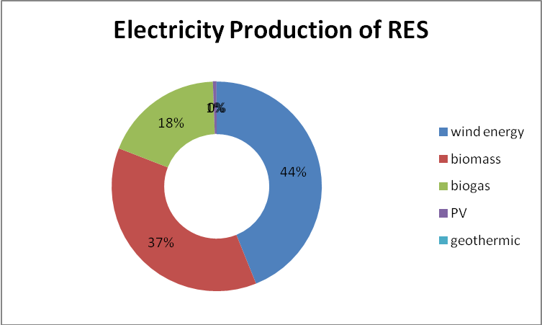
Figure 8: Portion of production from various RES in Austria
<http://www.e-control.at/de/marktteilnehmer/oeko-energie/zahlen-daten-fakten/oekostrommengen>, (15.05.2011)

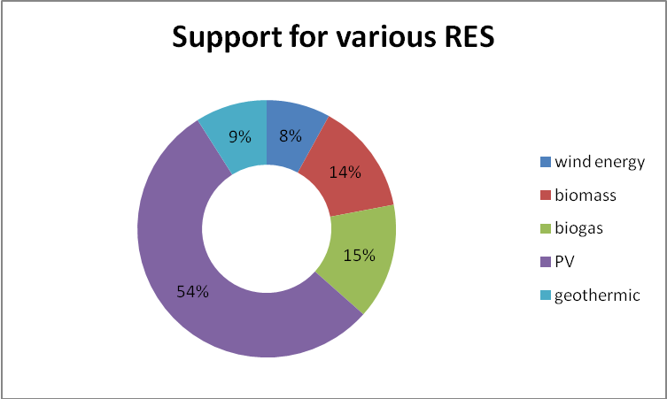
Figure 9:Portion of financial support for RES in Austria
<http://www.e-control.at/de/marktteilnehmer/oeko-energie/zahlen-daten-fakten/oekostrommengen>, (15.05.2011)

5. Impact on Electricity Prices
The impact of RES especially Photovoltaic on electricity prices, is not only because of the “RES tax”, but due to the technical problems, which caused unpredictability of production. There are additional costs hidden in strengthening transmission and distribution grid. The unpredictability of RES will result in higher system and support services cost. On the other hand, the fact that electricity from RES must be bought will result in lowering the price of power electricity on the market. In normal weather conditions the power electricity price will decrease by 0 – 3.5 EUR per MWh as shown on following figures. These tables are research result of impact solar power plants on power electricity price. (SOLAR BOOM IN CZECH REPUBLIC IN RELATION TO ELECTRICITY PRICES, Authors: Bems, Sokol)
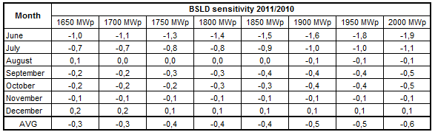
Figure 10: Base Load relative prices changes between years 2010/2011 for a range of 1650 Mwp - 2000 MWp of available capacities in PV
<(SOLAR BOOM IN CZECH REPUBLIC IN RELATION TO ELECTRICITY PRICES, Authors: Bems, Sokol)>, (03.05.2011)

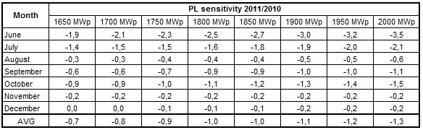
Figure 11: Peak Load relative price changes between years 2010/2011 for range of 1650 MWp - 2000 MWp of available capacities in PV
<(SOLAR BOOM IN CZECH REPUBLIC IN RELATION TO ELECTRICITY PRICES, Authors: Bems, Sokol)>, (03.05.2011)

6. Impact on Companies
We can divide companies into several groups such as energy producers, distribution and transport, sales and big industrial companies. We will not be put emphasis on small companies in this paper.

Producers, distributors and traders of electricity
This is very special group and the influence of renewables is significant. Regular producers of electricity (not from RES) can sell electricity for less money than before. The reason is the preference for renewable sources. Basically, the electricity from RES must be sold. After it is sold the regular producers can sell. The impact is shown in the tables above. Energy distribution companies are affected by the unpredictability of RES. They have to make large investments into renewable sources and into the development of the grid. There is a high impact from abroad, because a large electricity amount flows from the North of Germany to Austria through the Czech transmission grid. These additional costs affect also the distribution price. The last influenced group is the group of electricity traders. The markets are more volatile, so they are able to earn more money, but there are also higher risk factors.

Large industrial consumers of electricity
We put the main focus on industrial companies and tried to find out if the change in prices can be a serious problem for companies.
The first company we have focused on is SKODA AUTO a.s.The earnings after tax (EAT) are 376mil EUR for year 2010, exchange rate 25CZK/EUR. We have assumed power electricity price decrease by 2 EUR/MWh and support for RES at 17.6 EUR/MWh. Consumption of electricity was 479 000 MWh in the year 2010. We have performed sensitivity analysis, where changes in power electricity prices were in interval from -20 to 0 EUR and EAT was between 400 – 600 mil EUR. As we can see on the next figure, the changes in price of electricity will have a negative effect on EAT maximum about 10% in worst case. <www.skoda-auto.cz>, (13.05.2011)
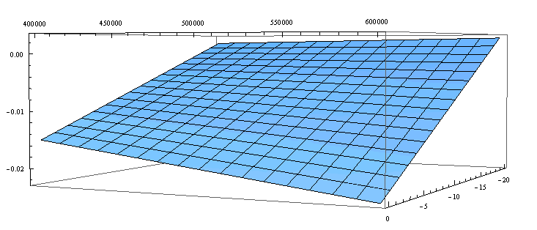
Figure 12: SKODA Auto a.s. (Sensitivity Analysis)
<own figure>, (13.05.2011)
The absolute change in EAT is calculated by following formula. Relative change which is displayed at graph is calculated as absolute EAT change divided by EAT. The corporate tax rate is 20% for Czech Republic.

The second company which we focused on is the Austrian VOEST Alpine, which is a steal-producer and a global partner for the automotive and energy industry. The year electricity consumption in 2010 is 64,687.25 MWh, the corporate tax rate in Austria is 25% and the EAT in 2010 is 700mil EUR. We have performed sensitivity analysis, where changes in power electricity prices were in interval from -20 to 0 EUR and EAT was between 500 – 700mil EUR.

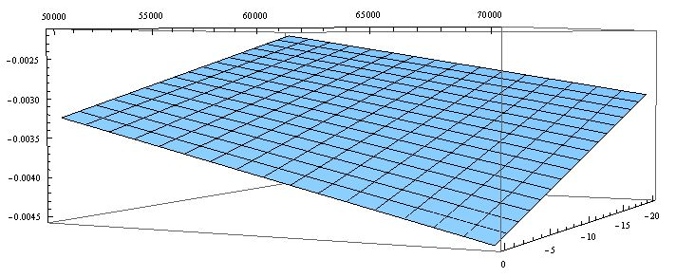
Figure 13: VOEST Alpine (Sensitivity Analysis)
<own figure>, (13.05.2011)

As we can see, the impact of price changes is not very high. The change in EAT is very small (between -0.35% to -0.45%). The ratio “electricity cost / revenues” is very low, so It doesn’t have any significant affect. We do have just a small effect for VOEST Alpine, because the energy consumption is quite low and the EAT is therefore relatively high. <http://www.voestalpine.com/group/de/>, (13.05.2011)

7. Conclusion
Although the electricity prices rise because of the higher use of RES, the two examples of the companies show, that there are much more factors, which influences the energy price and the impact on the companies. Right now the decisions of German government based on nuclear problem in Japan causes much higher impacts, than the renewable regulation. Therefore companies can never rely on stable prices and always have to be aware of energy savings and energy efficiency. The biggest difference is in the tempo of changes. Austrian natural conditions are much more suitable for RES than Czech. The EU requirements connected with inappropriate implementation of law by Czech politicians caused serious problems in energy sector and also high shock in prices for final consumers in Czech Republic. These changes were not so dramatic in Austria and even the price electricity is higher than in Czech Republic, the influence is not so dramatic.

References (Literature)
E-Control. 2011a. "Aktueller Marktpreis gemäß § 20 Ökostromgesetz", <http://www.e-control.at/de/statistik/oeko-energie/aktueller-marktpreis-gem-par-20-oekostromgesetz>, (15.05.2011)

E-Control. 2011b. "Ökostrom-Einspeismengen und Vergütung", <http://www.e-control.at/de/statistik/oeko-energie/oekostrommengen>, (15.05.2011)

European Commission. 2007. "Österreich – Fact Sheet Energymix", <http://ec.europa.eu/energy/energy_policy/doc/factsheets/country/at/mix_at_de.pdf>, (15.05.2011)

Österreich Energie. 2009. “Energie-Mix in Österreich”, <http://oesterreichsenergie.at/Energie-Mix_in_%C3%96sterreich_-_die_Quellen_des_heimischen_Stroms.html>, (15.05.2011)

SKODA a.s. 2011. "SKODA – Simply Clever", <http://www.skoda-auto.cz/CZE/Pages/homepage.aspx>, (03.05.2011)

VOEST Alpine. 2011. "Voest Alpine einen Schritt voraus", <http://www.voestalpine.com/group/de/>, (11.05.2011)

This price was set to 570 CZK/MWh, but additional taxation on photovoltaic producers allowed to lower it by 200 CZK/MWh

